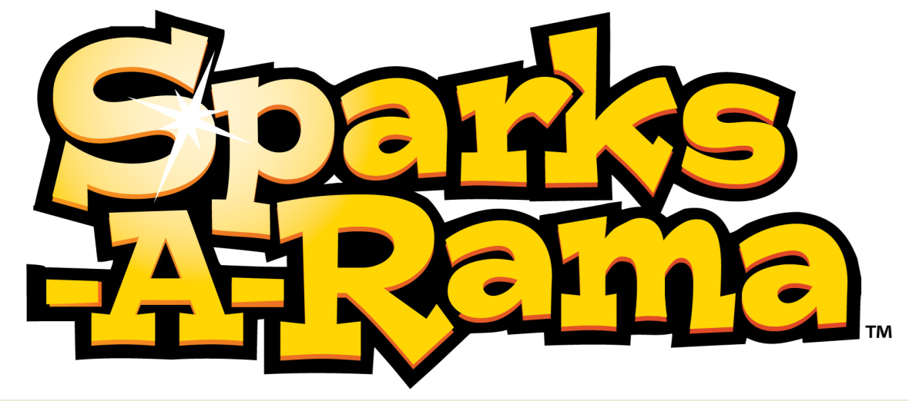
Sparky In & Out
2 Heats
10 Players each heat
Equipment Needed: 4 baskets, 4 colored beanbags

Sparky Safari
2 Heats – 1 Lap Each
1st Heat 4 Sparks
2nd Heat 4 Different Sparks
Equipment Needed: 4 Circle Pins, 4 Animals, 4 Scoring Pins, 4 Laundry Baskets

Sparky Bowl – 60 Seconds
6 Heats – 1 Lap
1st – 3rd Heats 1 Girl each heat
4th – 6th Heats 1 Boy each heat
Equipment Needed: 4 Colored beanbags,
4 Circle Pins, 1 Center Pin

Rabbit Hunt – 30 Seconds
4 Heats
10-15 Players/team
Equipment Needed: 2 Foam Sport Balls

Sparky Train
2 Heats – 1 Lap
1st Heat 5 Sparks,
2nd Heat 5 Different Sparks
Equipment Needed: 4 circle Pins,
4 scoring pins, 8 swimming pool noodles.

Sparky Ball Relay
2 Heats
10-15 Players, 1st Girl, 2nd Boy
Equipment Needed: 4 foam balls, 4 baskets, 4 colored scoring pins
Sparky In & Out
2 Heats
10 Players each heat
Equipment Needed: 4 baskets, 4 colored beanbags

Sparky Safari
2 Heats – 1 Lap Each
1st Heat 4 Sparks
2nd Heat 4 Different Sparks
Equipment Needed: 4 Circle Pins, 4 Animals, 4 Scoring Pins, 4 Laundry Baskets

Sparky Bowl – 60 Seconds
6 Heats – 1 Lap
1st – 3rd Heats 1 Girl each heat
4th – 6th Heats 1 Boy each heat
Equipment Needed: 4 Colored beanbags,
4 Circle Pins, 1 Center Pin

Rabbit Hunt – 30 Seconds
4 Heats
10-15 Players/team
Equipment Needed: 2 Foam Sport Balls

Sparky Train
2 Heats – 1 Lap
1st Heat 5 Sparks,
2nd Heat 5 Different Sparks
Equipment Needed: 4 circle Pins,
4 scoring pins, 8 swimming pool noodles.

Sparky Ball Relay
2 Heats
10-15 Players, 1st Girl, 2nd Boy
Equipment Needed: 4 foam balls, 4 baskets, 4 colored scoring pins
Sparky In & Out
2 Heats
10 Players each heat
Equipment Needed: 4 baskets, 4 colored beanbags

Sparky Safari
2 Heats – 1 Lap Each
1st Heat 4 Sparks
2nd Heat 4 Different Sparks
Equipment Needed: 4 Circle Pins, 4 Animals, 4 Scoring Pins, 4 Laundry Baskets

Sparky Bowl – 60 Seconds
6 Heats – 1 Lap
1st – 3rd Heats 1 Girl each heat
4th – 6th Heats 1 Boy each heat
Equipment Needed: 4 Colored beanbags,
4 Circle Pins, 1 Center Pin

Rabbit Hunt – 30 Seconds
4 Heats
10-15 Players/team
Equipment Needed: 2 Foam Sport Balls

Sparky Train
2 Heats – 1 Lap
1st Heat 5 Sparks,
2nd Heat 5 Different Sparks
Equipment Needed: 4 circle Pins,
4 scoring pins, 8 swimming pool noodles.

Sparky Ball Relay
2 Heats
10-15 Players, 1st Girl, 2nd Boy
Equipment Needed: 4 foam balls, 4 baskets, 4 colored scoring pins

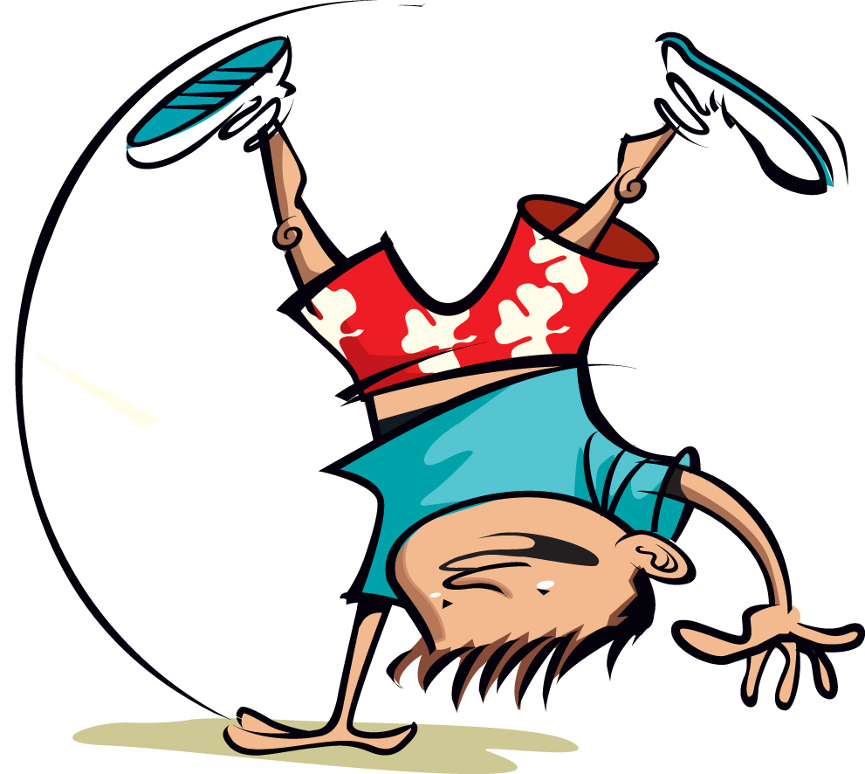
T&T Games

Beanbag Relay
3 Heats
1st heat 5 girls
2nd heat 5 boys
3rd heat – 5 boys & 5 girls
Equipment Needed: 4 circle pins,
4 colored beanbags, 4 scoring pins

Sprint Relay
2 Heat – 1 Lap Each
1st heat - Two 3rd/4th grade girls
One 5th/6th grade girl
2nd heat - Two 3rd/4th grade boys
One 5th/6th grade boy
Equipment Needed: 4 circle pins,
4 batons, 4 scoring pins

Beanbag Bonanza
2 Heats
1st heat - 5 girls
2nd heat - 5 boys
Equipment Needed: 4 scoring pins,
4 colored beanbags, 4 striped beanbags,
4 circle pins

Three legged Race
4 Heats – 2 Laps Each
1st heat – Two 3rd/4th grade girls
2nd heat – Two 3rd/4th grade boys
3rd heat - Two 5th/6th grade girls
4th heat – Two 5th/6th grade boys
Equipment Needed: 4 circle pins,
4 scoring pins, 4 leg bands

Sprint Race
2 Heats – 3 Laps Each
1st heat – One 3rd/4th grade girl
2nd heat – One 3rd/4th grade boy
Equipment Needed: 4 circle pins,
4 scoring pins

T&T Games

Beanbag Relay
3 Heats
1st heat 5 girls
2nd heat 5 boys
3rd heat – 5 boys & 5 girls
Equipment Needed: 4 circle pins,
4 colored beanbags, 4 scoring pins

Sprint Relay
2 Heat – 1 Lap Each
1st heat - Two 3rd/4th grade girls
One 5th/6th grade girl
2nd heat - Two 3rd/4th grade boys
One 5th/6th grade boy
Equipment Needed: 4 circle pins,
4 batons, 4 scoring pins

Beanbag Bonanza
2 Heats
1st heat - 5 girls
2nd heat - 5 boys
Equipment Needed: 4 scoring pins,
4 colored beanbags, 4 striped beanbags,
4 circle pins

Three legged Race
4 Heats – 2 Laps Each
1st heat – Two 3rd/4th grade girls
2nd heat – Two 3rd/4th grade boys
3rd heat – Two 5th/6th grade girls
4th heat – Two 5th/6th grade boys
Equipment Needed: 4 circle pins,
4 scoring pins, 4 leg bands

Sprint Race
2 Heats – 3 Laps Each
1st heat – One 3rd/4th grade girl
2nd heat – One 3rd/4th grade boy
Equipment Needed: 4 circle pins,
4 scoring pins

T&T Games

Beanbag Relay
3 Heats
1st heat 5 girls
2nd heat 5 boys
3rd heat – 5 boys & 5 girls
Equipment Needed: 4 circle pins,
4 colored beanbags, 4 scoring pins

Sprint Relay
2 Heat – 1 Lap Each
1st heat - Two 3rd/4th grade girls
One 5th/6th grade girl
2nd heat - Two 3rd/4th grade boys
One 5th/6th grade boy
Equipment Needed: 4 circle pins,
4 batons, 4 scoring pins

Beanbag Bonanza
2 Heats
1st heat - 5 girls
2nd heat - 5 boys
Equipment Needed: 4 scoring pins,
4 colored beanbags, striped beanbags,
4 circle pins

Three legged Race
4 Heats – 2 Laps Each
1st heat – Two 3rd/4th grade girls
2nd heat – Two 3rd/4th grade boys
3rd heat – Two 5th/6th grade girls
4th heat – Two 5th/6th grade boys
Equipment Needed: 4 circle pins,
4 scoring pins, 4 leg bands

Sprint Race
2 Heats – 3 Laps Each
1st heat – One 3rd/4th grade girl
2nd heat – One 3rd/4th grade boy
Equipment Needed: 4 circle pins,
4 scoring pins
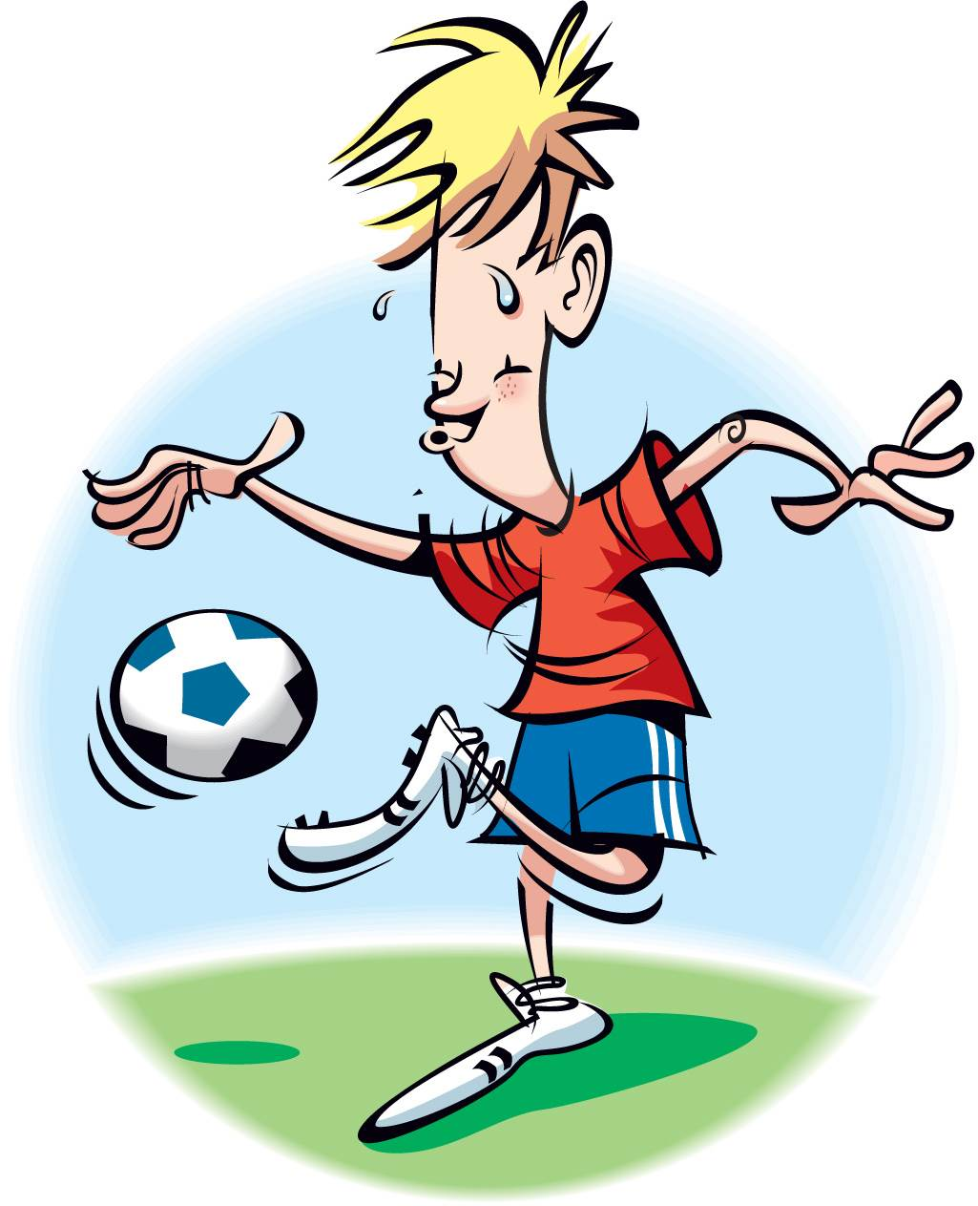

Four-way Tug
2 heats
1st heat – Two 5th/6th grade girls
2nd heat – Two 5th/6th grade boys
Equipment Needed: 1 tug rope,
4 colored beanbags

Knock it Down
6 Heats
1st – 3rd Heat – One Girl
4th – 6th Heat – One Boy
4 colored bean bags, 4 colored scoring pins, 4 circle pins

Marathon Relay
2 Heats – 2 Laps Each
1st heat - One 3rd/4th grade girl
Two 5th/6th grade girls
2nd heat - One 3rd/4th grade boy
Two 5th/6th grade boys
Equipment Needed: 4 circle pins,
4 batons, 4 colored scoring pins

Marathon Race
2 Heats – 6 Laps
1st heat – One 5th/6th grade girl
2nd heat – One 5th/6th grade boy
Equipment Needed: 4 circle pins,
4 scoring pins

Ball Relay
2 Heats
1st heat - 5 girls
2nd heat - 5 boys
Equipment Needed: 4 foam balls,
4 scoring pins – at 5ft. mark

Four-way Tug
2 heats
1st heat – Two 5th/6th grade girls
2nd heat – Two 5th/6th grade boys
Equipment Needed: 1 tug rope,
4 colored beanbags

Knock it Down
6 Heats
1st – 3rd Heat – One Girl
4th – 6th Heat – One Boy
4 colored bean bags, 4 colored scoring pins, 4 circle pins

Marathon Relay
2 Heats – 2 Laps Each
1st heat - One 3rd/4th grade girl
Two 5th/6th grade girls
2nd heat - One 3rd/4th grade boy
Two 5th/6th grade boys
Equipment Needed: 4 circle pins,
4 batons, 4 colored scoring pins

Marathon Race
2 Heats – 6 Laps
1st heat – One 5th/6th grade girl
2nd heat – One 5th/6th grade boy
Equipment Needed: 4 circle pins,
4 scoring pins

Ball Relay
2 Heats
1st heat - 5 girls
2nd heat - 5 boys
Equipment Needed: 4 foam balls,
4 scoring pins – at 5ft. mark

Four-way Tug
2 heats
1st heat – Two 5th/6th grade girls
2nd heat – Two 5th/6th grade boys
Equipment Needed: 1 tug rope,
4 colored beanbags

Knock it Down
6 Heats
1st – 3rd Heat – One Girl
4th – 6th Heat – One Boy
4 colored bean bags, 4 colored scoring pins, 4 circle pins

Marathon Relay
2 Heats – 2 Laps Each
1st heat - One 3rd/4th grade girl
Two 5th/6th grade girls
2nd heat - One 3rd/4th grade boy
Two 5th/6th grade boys
Equipment Needed: 4 circle pins,
4 batons, 4 colored scoring pins

Marathon Race
2 Heats – 6 Laps
1st heat – One 5th/6th grade girl
2nd heat – One 5th/6th grade boy
Equipment Needed: 4 circle pins,
4 scoring pins

Ball Relay
2 Heats
1st heat - 5 girls
2nd heat - 5 boys
Equipment Needed: 4 foam balls,
4 scoring pins – at 5ft. mark

